Afro-American Alumni Awards

Paul Gaines Sr. Afro-American Alumni Achievement Award

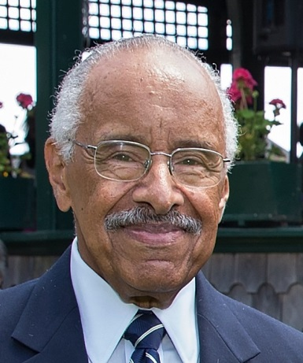
The Afro-American Alumni Achievement Award is named for Paul Gaines Sr., ’68, who was the first appointed Minority Affairs Director at Bridgewater State College (1968 – 1995). Mr. Gaines began actively recruiting students of color into the college and was the pioneer in hiring of professors, administrators, and other staff of color on the Bridgewater Campus. He championed their cause and made sure potential students and employees were given a fair and impartial application and interview process for the various jobs on the campus. Many alumni and employees have benefitted from Mr. Gaines' steady guidance at a time when social acceptance was uncertain. During his tenure, Mr. Gaines founded the Organization of Afro-American Students in 1968, which later was named the Afro-Am Society. In 1990, the Afro-American Alumni Association was officially formed.

Created in 2013, the award was renamed in 2016 in honor of Paul Gaines Sr. The award is given to a current faculty, administrator, library or staff member that has been employed at least one year at Bridgewater State University who has worked on behalf of students of color. The individuals distinguished by the award are intended to be those who have the respect and even the affection of the students. The recipient(s) will be selected based on the following criteria:

Selection Criteria:

- The nominee(s) must demonstrate a deep commitment in the growth and retention of students of color at Bridgewater State University.
- The nominee(s) must support of the Afro-American Alumni Association through programming and/or events.
- The nominee(s) may or may not be an Alumnus of Bridgewater State University.
- The nominee(s) must be present to accept the award at the Annual Awards Dinner in March.

Selection Process:

- Only a member of the Afro-American Alumni Association can make nominations.
- The consideration and processing of the nomination shall take place once a year.
- Nominees will be reviewed by the Awards Committee then narrowed to two candidates for a vote by the Executive Board & Alumni Council. Nominee must receive a majority vote to be selected.
- Nominees who are not selected may be re-nominated.
- A maximum of two awards may be presented each year.

